Does the medical education in Egyptian medical schools match the WHO Guidelines for Quality Assurance of Basic Medical Education in Student Perception?

Shreen Mostafa Mahmoud¹, Ummu Helma Binti Hassan¹, Nourhan Mohamed Sayed¹, Mohammad Busyoiri Bin Norrodin¹, Farah Issa Abdel Kader¹, Chiranjibi Mainali¹, Abdullahi Dahir Aden¹, Aftab Alam Ansari¹, Amira Etman², Sarah Abdelhamid Ibrahim Marzouk³, Abdelrahman Essam El-Din Bayoumi⁴ and Ahmed Magdy⁵

¹Kasr Al Ainy Medical School, Cairo University, ²Faculty of Medicine, Menoufia University, ³El Demerdash Hospital, ⁴Faculty of Science, Cairo University, ⁵Faculty of Medicine, Benha University

email: mrs.group9@gmail.com

ABSTRACT:
Introduction: This study evaluates students’ satisfaction with quality of education in their medical school. Method: Data were collected using a questionnaire distributed among 100 students of six medical schools in Egypt. Students’ satisfaction of five areas associated with their medical education is assessed. Result: The average percentage of students satisfaction with the education quality in all five areas are discovered to be (dissatisfied: 46.7%), with neutral response (44.6%) and satisfactory response of (8.6%). The highest percentage of satisfaction (45%) was shown in area 1, of syllabus mission and objectives while the lowest percentage of student satisfactions (7.25%) was shown in area 6, of educational resources. Conclusion: The findings of the study showed that students' satisfaction with medical education quality in their respective medical school is generally low.

Keywords: student satisfaction, medical education quality, Egypt

INTRODUCTION:
In the last period, there was an increase demand in the quality of education and healthcare in Egypt with the increase in globalization of medicine, as manifested in growing number of migrating doctors, so we need to maximize the effectiveness and efficiency of education and training, as ’the knowledge, skills, attitudes and behaviors have become necessary for safe and effective practice’.

In 2005, the world Health Organization (WHO) and World federation of Medical Education (WFME) published Guidelines for Accreditation of Basic Medical Education⁽¹⁾, These guidelines recommend establishment of proper accreditation systems that are effective, independent, and transparent and based on medical education specific criteria.

Accreditation programs have been implemented in Egypt in the recent years, it was started in primary health care and hospitals then extended to medical schools. Cairo, Alexandria, Al-Mansoura, Suez Canal, Al-Menoufyia, Tanta and Ain-Shams universities have already received accreditation.

In our study, we want to know the Egyptian medical students’ opinion if these schools meet the WHO Guidelines for Quality Assurance of Basic Medical Education. We aimed to determine the extent of accreditation of some Egyptian medical schools on students' satisfaction; do these schools fulfill the standard criteria from the students' point of view? The purpose of the study is also to find out the weakness and pave the way to improve them for a better quality of education and health care in Egypt.

METHODS:
Data was collected from 28th of October to 29 November 2014. Over 100 samples were collected by using Google form or handed over by hard copies.

Study Design:
A cross sectional study depending on an online multiple-item questionnaire based on random sampling technique. The questionnaire is based on the WHO guidelines for quality assurance of basic medical education.

Study population:
Data was collected from both sex and different grades and mainly medical students of most of Egyptian universities with inclusion criteria:
1. Undergraduate medical students and interns.
2. They must belong to an accredited medical school: Cairo, Ain- Shams, Alexandria, Mansoura, Menoufyia, Tanta, Assuit, Zagazig and Al- Azhar.

Statistical Analysis:
The collected data are checked, coded and compared by percentage of students’ satisfaction and dissatisfaction

RESULTS:
The sample was collected from 6 main medical schools in Egypt, highest response was from Kasr Al Ainy (62%), followed by Menoufyia(22%), Zagazig(7%), Ain Shams & Al Azhar; each by(4%), then Mansoura (1%).

27% of the students were from the 2nd grade, 21% from the 4th, 14% from the 5th, and 3rd grade respectively. 13% from the 6th grade, 6% at their internship year and only 5% from the 1st grade.

Our questionnaire was based on the WHO guidelines for assessment of medical education which consists of 9 main areas from which 5 areas were chosen to be assessed by students' opinions.

(N=100)
Area 1. MISSION AND OBJECTIVES :

58% of the students agreed that their medical school provides a copy of its general mission and objectives but only 32% think that their medical school can feedback the assessment of their competences into course development.

[Figure 1 : Assessment of Syllabus]

Average student satisfaction: 45%

AREA 2. EDUCATIONAL PROGRAMME AND PRINCIPLES :
45% think that the design of the curriculum and the way of teaching encourages students and prepares them for life-long learning in a below average way , 45% think it's average, and only 10% think it's above average.

48% think that critical thinking, evidence based medicine and scientific training is promoted and taught in their medical school in a below average way , 43% think it's average , and only 9% think it's above average

56% think that Behavioral, social sciences, and medical ethics are considered in the health care practice in an average way , 34% think it's below average , and 10% think it's above average

56% think that Health promotion and preventive medicine are dealt with in the curriculum in an average way, 30% think it's below average, and 14% think it's above average

56% think that their medical school monitors assessment to reduce curriculum overload and encourage integration in a below average way, 38% think that it’s average, and 6% think it’s above average.

47% think that the system adjusting time schedule for lectures is not effective , but 28% think it's effective, and 25% think that there is no system at all.

Average student satisfaction: 12.8%

AREA 4. STUDENTS:
41% think that the programs for students support and counseling are not effective, 38% think it's not found at all, 21% think that it's effective .

52% think that there are no practical measures to encourage students' participation in curriculum policy matters, 33% think that they're found but not effective, and 15% think that they are effective .

Average student satisfaction: 18%

AREA 6. EDUCATIONAL RESOURCES:
55% think that their medical school adjusts and expands the use of clinical training facilities including skills, laboratories and institutions in an average way , 36% think that this is below average , 9% think this is above average.

50% think that their medical school delivery of curriculum by modern electronic methods and facilities is average, 41% think it's below average, and 9% think it's above average .

61% think that their medical school encourages interaction between research and educational activities in a below average way, 35% think that it's average, and 4% think that this is above average .

61% think that in their medical schools the Prevalence of activities directed towards regional and international co-operation with other medical schools is below average, 32% think that this is average , and 7% think that it's above average.

Average student satisfaction: 7.25%

AREA 7. MONITORING AND EVALUATION OF PROGRAMMES AND COURSES

45% think that in their medical school, there is a process of regular sampling of staff and students opinions about educational programs but it's not effective , 44% think that it's not found at all, but 11% think that it's found and effective .

46% think that there is no collected or analyzed statistical data assessing student performance, 36% think that it's found but not affecting curricular planning and
18% think that it's found and effective.
Average student satisfaction: 14.5%

N.B. : AREAS (3) , (5) , (8) & (9) :
Were excluded as we thought that they're difficult to be assessed by students' opinion.

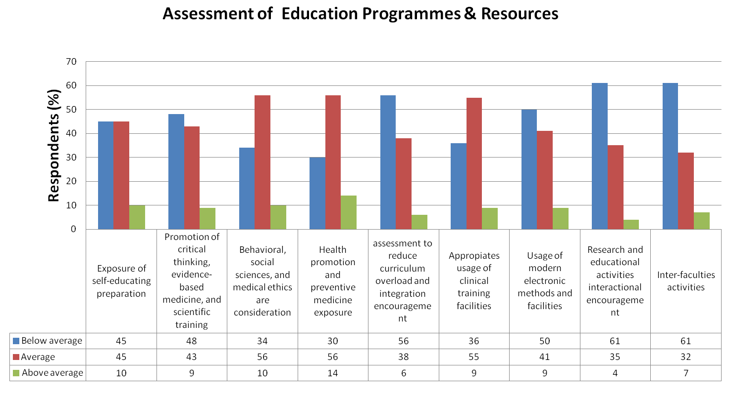
[Figure 2 : Assessment of Education Programmes & Resoures]

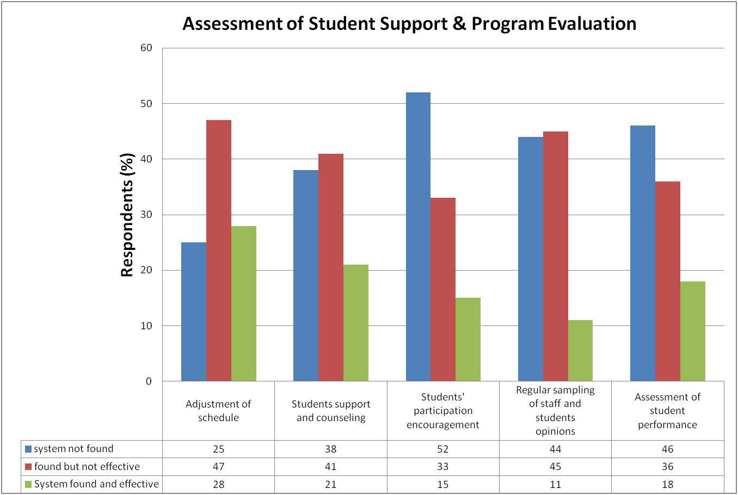
[Figure 3 : Assessment of Student Support & Program Evaluation]

DISCUSSION:

The current study is based on student perception of their respective medical school quality, according to the criteria listed by WHO. Based on the assessment done, comparison between five areas study show that the average percentage of students satisfactory response (above average/effective) are only 8.6%, while neutral response (average/ineffective) is 44.6% and dissatisfied responses (below average/not found at all) is 46.7%.

The study revealed that although the syllabus mission and objectives are stated, students do not find it fruitful for feedback assessment. This inadequacy should be addressed as Prosser and Trigwell mentioned that learning does not only depend on how teachers have planned their courses and subjects, but also upon how their students understand this planning. ⁽⁶⁾

This study showed that students are strongly dissatisfied with educational programme and principle that are very lacking in critical thinking, evidence based medicine, scientific training and are not conducive for lifelong learning. There is also dissatisfaction with lack of integration and ineffective schedule changes. This may be due to academic orientation of medical school in Egypt that focuses too much on examination. Even so, preventive care and medical ethics is found to be well implemented in the curriculum as shown by student neutral respond to it.

The study also indicates student dissatisfaction with support services. It may be attributed to lack of facility to help students coping their undergraduate year on campus. This contradict with emphasize by current literature on the need for student support services that can interfere with performance in academic settings related to varying educational and psychosocial factors^{(7,8)}. Students are also dissatisfied with lack of promotive measure to encourage students involvement in shaping curriculum policy.

The study showed that the students are dissatisfied with the educational resources they have in their medical schools and this is probably because the usage of the clinical training facilities including skills, laboratories and institutions is very limited.
The dissatisfaction with the educational resources can also be attributed to the lack of interaction between research and educational activities including activities directed towards regional and international co-operation with other medical schools.

The study showed also that students are strongly dissatisfied with the monitoring and the evaluation procedures of programs and courses and this may be due to the ineffectiveness of the regular sampling of staff and students opinions about educational programs process and the absence of statistical data assessing student’s performance and curricular planning.
CONCLUSION:

Students' satisfaction has a role as an outcome of educational process because of its potential influence in their academic achievement and motivation. It will also be reflected later on in their professional attitudes, career and commitment in medical profession ⁽⁹⁾. Therefore it will be affecting the quality of graduates. The findings of this study suggest quality of education should be reevaluated in our university with specific attention to syllabus content, student support, system administration and others. Based on the present findings, it is recommended that inadequacy in the previous area mentioned should be highlighted to policy makers, educational administrators and staff members to optimize the process to achieve educational goals.

LIMITATIONS:
The study was limited to only 100 students of 6 universities in Egypt, a larger sample size may yield a more nuanced results.

FURTHER STUDY:
Future studies are recommended to include more medical schools with assessment of student satisfaction from a wider angle encompassing all aspect of their education and to explore the relationship between student satisfaction and education outcome. The result should be assessed according to respective medical school for comparison and plan management to be taken by the medical school.
REFERENCES:

1-“WHO Guidelines for Quality Assurance of Basic Medical Education in the Western Pacific Region.”

2- Karle, H. (2006). Global standards and accreditation in medical education: a view from the WFME.Academic medicine, 81(12), pp.43--48.

3- Karle, H. (2008). World Federation for Medical Education Policy on international recognition of medical schools’ programme. Ann Acad Med Singapore, 37, pp.1041--1043.

4- Johnson, P., Fogarty, L., Fullerton, J., Bluestone, J. and Drake, M. (2013). An integrative review and evidence- based conceptual model of the essential components of pre-service education. Meta, 1, p.1.

5- Karle, H. (2008). International recognition of basic medical education programmes. Medical education, 42(1), pp.12-17.

6- Al Tehewy, M., Salem, B., Habil, I. and El Okda, S. (2009). Evaluation of accreditation program in non-governmental organizations' health units in Egypt: short-term outcomes. International Journal for Quality in Health Care, 21(3), pp.183—189

7- Shaikh BT, Kahloon A, Kazmi M, Khalid H, Nawaz K, Khan N, et al. Students, stress and coping strategies: A case of Pakistani medical school. Educ Health (Abingdon) 2004;17:346‑53.

8- Sayer M, De Saintonge M, Evans D, Wood D. Support for students with academic difficulties. Med Educ 2002;36:643‑50

9- Cherniss C. Career commitment in human service professional: a biographical study. Human relations. 1991; 44: 419-37.

10- “Bahrain Med Bull 2012; 34(1):,” 34 (2012), 1–6.

APPENDIX
Medical Student Survey
Introduction

1-Name:
2- Group (only if you are MRS applicant):
3- Medical School:
4- Grade:

Questions

1-Your medical school provides a copy of its general mission and objectives:
Yes
No

2- Your medical school measures the competencies of its graduates and feedback this information into course development:
Yes
No

3- The design of the curriculum and the way of teaching encourages students and prepares them for life-long learning:
A. Below average
B. Average
C. Above average

4- Critical thinking, evidence based medicine and scientific training is promoted and taught in your medical school:
A. Below average
B. Average
C. Above Average

5- Behavioral, social sciences, and medical ethics are considered in the health care practice:
A. Below average
B. Average
C. Above average

6- Health promotion and preventive medicine are dealt with in the curriculum:
A. Below average
B. Average
C. Above average

7- The medical school monitors assessment to reduce curriculum overload and encourage integration:
A. Below average
B. Average
C. Above average

8- There is effective system adjusting time schedule for lectures:
A. Not found at all
B. Found but not effective
C. Found and effective

9- There are specific programs for students support and counseling:
A.Not found at all
B. Found but not effective
C. Found and effective

10- There are practical measures to encourage medical students’ participation in curriculum policy matters:
A. Not found at all
B. Found but not effective
C. Found and effective

11- Your medical school adjusts and expands the use of clinical training facilities including skills, laboratories and institutions:
A. Below average
B. Average
C. Above Average

12- Your medical school delivery of curriculum by modern electronic methods and facilities is:
A. Below average
B. Average
C. Above average

13-Your medical school encourages interaction between research and educational activities:
A. Below average
B. Average
C. Above Average

14- Prevalence of activities directed towards regional and international co-operation with other medical schools:
A. Below average
B. Average
C. Above average

15- In your medical school, there is a process of regular sampling of staff and students opinions about educational programs:
A. Not found at all
B. Found but not effective
C. Found and effective

16- Statistical data on student performance is regularly collected and analyzed to affect curricular planning:
A. Not found at all
B. Found but not effective
C. Found and effective

